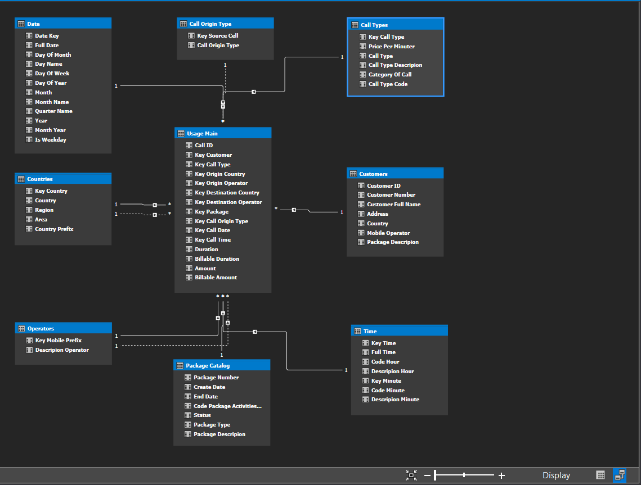Diagram Of Tabular Model:

That Relationship Of Tables:

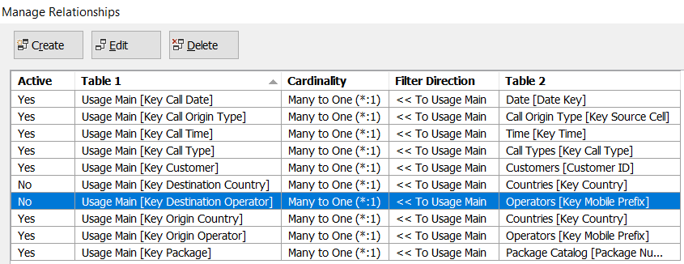We can see here that inactive relationship are connected, to fix this we need to create two new tables and dissociate double connections.

On the next page you can see the Fix with the addition of two identical tables:

Countries and Operators.

Fix Diagram Of Tabular Model: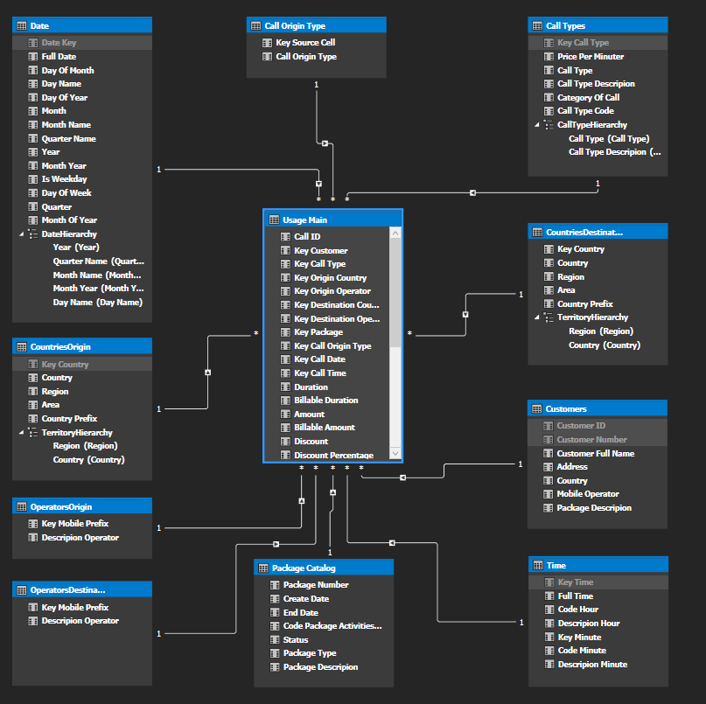

Fix Relationship Of Tables: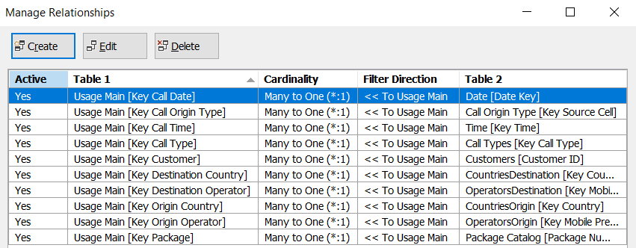

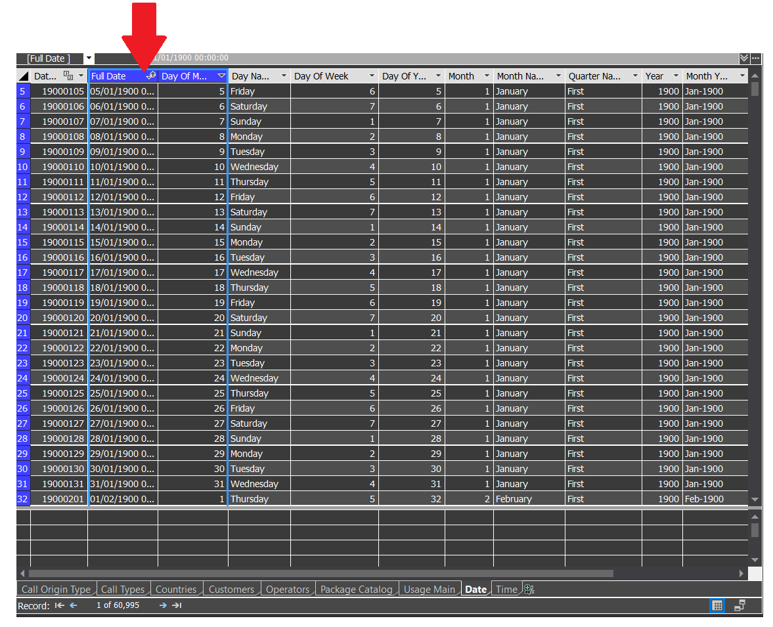Sort Active Of Date Table:

Sort By Column:

In the Date table, go to Properties and under the Sort by Column field change according to the column (Integer Values).

For example:

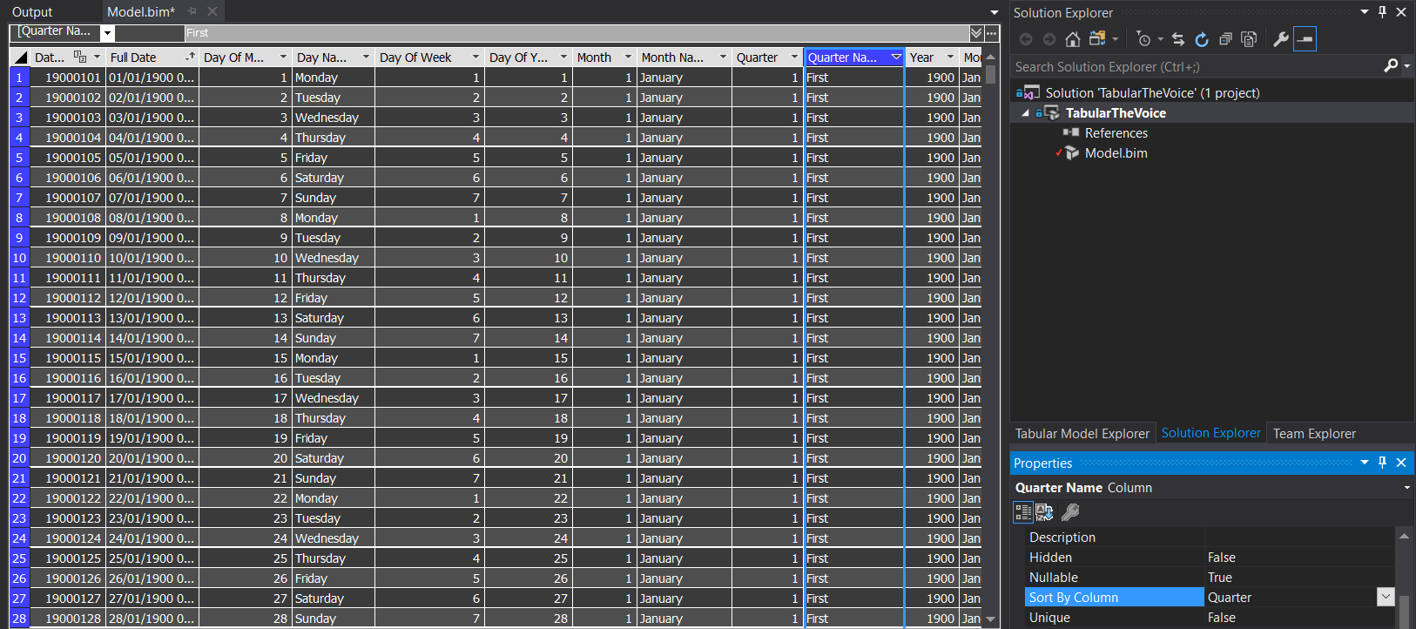The Column Quarter Name we are changed the Sort by Column field to Quarter.

We did the same thing in Columns:

Month Name 🡪 Month.

Day Name 🡪 Day Of Week.

Month Year 🡪 Month Of Year = Format('Date'[Full Date ],"YYYYMM").

The Calculated Columns (Grey Columns):

We created two computed columns using the DAX language.

* The first column is Discount. Writing the calculation is:

Discount : = 'Usage Main'[Amount] - 'Usage Main'[Billable Amount]

* The second column is Discount Percentage. Writing the calculation is:

Discount Percentage : = 'Usage Main'[Discount] / 'Usage Main'[Amount]

We are changed the format of calculated column Discount Percentage in properties (without a number after a point)

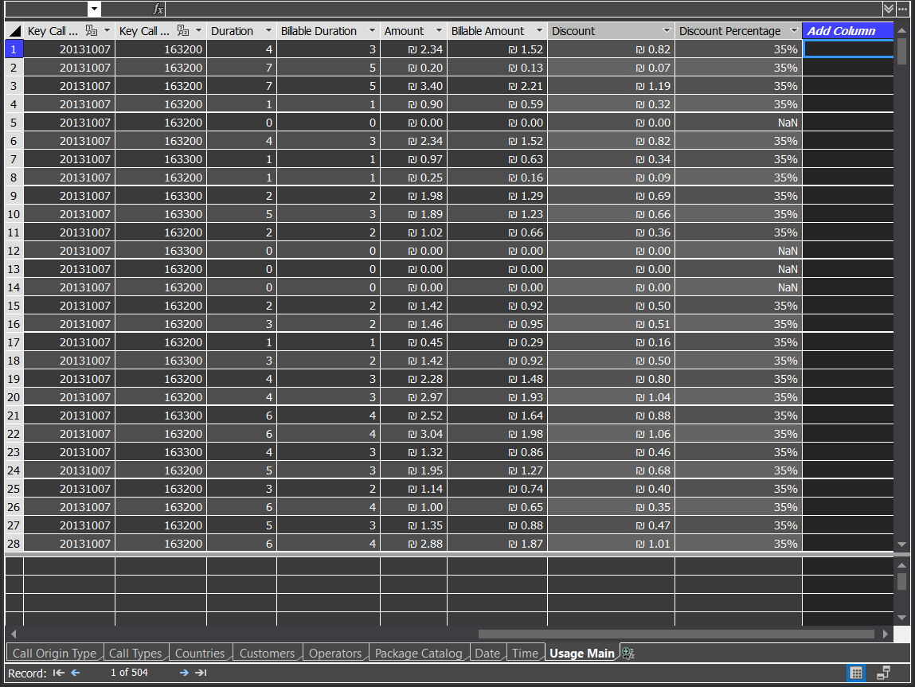

Deploy Project in Tabular Model processing progress:

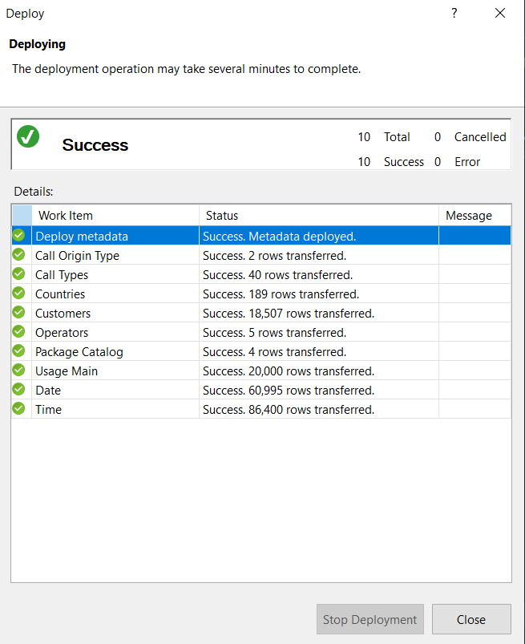

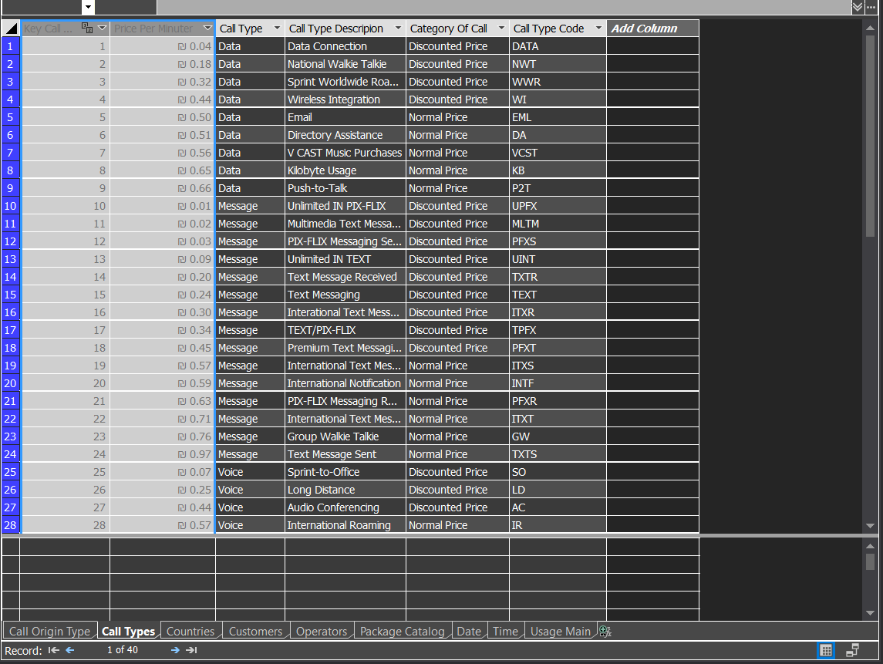Hidden a Column from a Client:

Create Hierarchy on Diagram Model:

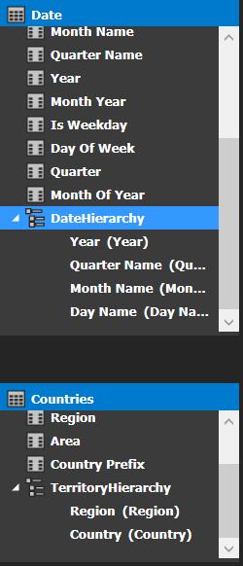

Here we can show tow Hierarchies.

:Hierarchy of Date

:Hierarchy of Territory

We reduced the columns to get faster performance:

